Supplementary Materials for
Increases in COVID-19 is unrelated to Levels of Vaccination across 68 countries and 2,947 counties in the United States
S V Subramanian*, Akhil Kumar
*Corresponding Author, Email: svsubram@hsph.harvard.edu

Figure S1: Relationship between Cases per 1 Million People (Last 7 Days) and Population Fully Vaccinated (%) 1 Month Lag across Countries as of September 3rd, 2021………………………………………………………………………………………………2
Figure S2: Median, Interquartile Range and Variation in Cases per 100,000 People in the Last 7 Days across Population Fully Vaccinated (%) 1 Month Lag as of September 2nd, 2021………………………………………………………………………………………………3
Table S1: Country Names, Cases in the Last 30 Days, Fully Vaccinated, and Population Metrics for 68 countries as of September 3rd, 2021…………………………………………4
Table S2: Interactive Online Data underlying the analysis as of September 2nd, 2021 (Updated from the COVID-19 Community Profile Report of the White House COVID-19 Team)……………………………………………………………………………………………..7

Figure S1: Relationship between Cases per 1 Million People (Last 7 Days) and Population Fully Vaccinated (%) 1 Month Lag across 68 Countries as of September 3rd, 2021
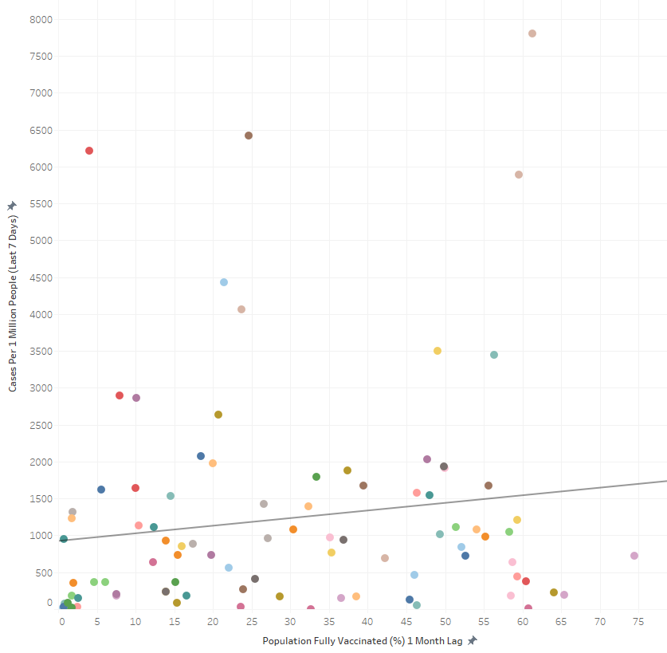

Figure S2: Median, Interquartile Range and Variation in Cases per 100,000 People in the Last 7 Days across Population Fully Vaccinated (%) 1 Month Lag as of September 2nd, 2021
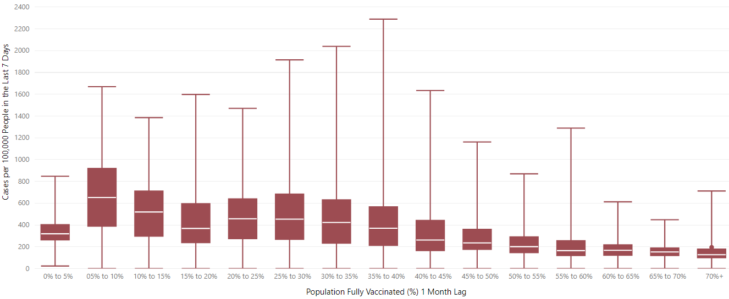

Table S1: Country Names, Cases in the Last 30 Days, Fully Vaccinated, and Population Metrics for 68 countries as of September 3rd, 2021
Country Name | Cases in the Last 7 Days | People Fully Vaccinated | People Fully Vaccinated % of Population | Population | Cases Per 1 Million People in the Last 7 Days
Angola | 1055 | 920570 | 2.71 | 33933611 | 31.09011888
Argentina | 29022 | 14786884 | 32.42 | 45605823 | 636.3661061
Australia | 7744 | 7316462 | 28.37 | 25788217 | 300.2921838
Austria | 8536 | 5213214 | 57.65 | 9043072 | 943.9270195
Azerbaijan | 23194 | 2731755 | 26.72 | 10223344 | 2268.729292
Bahrain | 593 | 1089404 | 62.31 | 1748295 | 339.1876085
Botswana | 3134 | 207695 | 8.66 | 2397240 | 1307.336771
Brazil | 127654 | 63515389 | 29.68 | 213993441 | 596.5323021
Bulgaria | 9056 | 1180497 | 17.12 | 6896655 | 1313.100336
Cambodia | 2552 | 8594733 | 50.72 | 16946446 | 150.5920474
Canada | 20429 | 25480478 | 66.93 | 38067913 | 536.6461776
Cyprus | 1599 | 522561 | 58.85 | 888005 | 1800.665537
Czechia | 1145 | 5744569 | 53.56 | 10724553 | 106.7643565
Djibouti | 45 | 23797 | 2.37 | 1002197 | 44.90135173
Egypt | 1573 | 3208954 | 3.08 | 104258327 | 15.0875239
Georgia | 21526 | 421785 | 10.6 | 3979773 | 5408.851208
Greece | 17227 | 5748030 | 55.43 | 10370747 | 1661.114672
Hong Kong | 36 | 3475566 | 46.02 | 7552800 | 4.766444233
Iceland | 413 | 263778 | 76.82 | 343360 | 1202.819199
India | 254749 | 151908785 | 10.9 | 1393409033 | 182.8242777
Indonesia | 56402 | 36454433 | 13.19 | 276361788 | 204.0875492
Israel | 54710 | 5494200 | 62.51 | 8789776 | 6224.276933
Italy | 36876 | 36850735 | 61.04 | 60367471 | 610.8587852
Jamaica | 4188 | 145171 | 4.88 | 2973462 | 1408.45923
Japan | 117481 | 59060074 | 46.85 | 126050796 | 932.0131544
Kazakhstan | 32185 | 5438316 | 28.63 | 18994958 | 1694.397008
Kenya | 4012 | 806404 | 1.47 | 54985702 | 72.96442264
Kyrgyzstan | 1063 | 456482 | 6.89 | 6628347 | 160.3718091
Latvia | 1420 | 765302 | 40.99 | 1866934 | 760.6053562
Lebanon | 6434 | 1093360 | 16.15 | 6769151 | 950.4884734
Libya | 8460 | 58539 | 0.84 | 6958538 | 1215.772624
Lithuania | 3436 | 1514850 | 56.32 | 2689862 | 1277.388952
Malawi | 493 | 426390 | 2.17 | 19647681 | 25.09201977
Malaysia | 124173 | 15241655 | 46.5 | 32776195 | 3788.511754
Mali | 92 | 86477 | 0.41 | 20855724 | 4.411258991
Malta | 297 | 412767 | 80.22 | 514564 | 577.1876773
Mauritania | 1004 | 22120 | 0.46 | 4775110 | 210.2569365
Mauritius | 2009 | 748954 | 58.81 | 1273428 | 1577.631401
Mongolia | 15800 | 2097056 | 62.99 | 3329282 | 4745.768006
Montenegro | 3456 | 184986 | 29.45 | 628051 | 5502.737835
Namibia | 861 | 115624 | 4.47 | 2587344 | 332.7736861
Nepal | 9380 | 4667328 | 15.73 | 29674920 | 316.0918378
New Zealand | 348 | 1239351 | 25.5 | 4860642 | 71.5954806
North Macedonia | 4742 | 539037 | 25.88 | 2082661 | 2276.894799
Pakistan | 23416 | 18004529 | 7.99 | 225199929 | 103.9787184
Panama | 3279 | 1661524 | 37.92 | 4381583 | 748.3596682
Philippines | 104755 | 14109916 | 12.71 | 111046910 | 943.3400713
Portugal | 11071 | 7627146 | 75.01 | 10167923 | 1088.816271
Russia | 109953 | 37258029 | 25.53 | 145912022 | 753.5568248
Sao Tome and Principe | 57 | 11881 | 5.32 | 223364 | 255.1888397
Saudi Arabia | 1324 | 15076611 | 42.66 | 35340680 | 37.46390845
Senegal | 605 | 564998 | 3.29 | 17196308 | 35.18197046
Slovenia | 2803 | 907873 | 43.67 | 2078723 | 1348.424008
Somalia | 450 | 97425 | 0.6 | 16359500 | 27.50695315
South Africa | 52230 | 6145216 | 10.23 | 60041996 | 869.8911342
South Korea | 10243 | 16283360 | 31.74 | 51305184 | 199.648441
Sri Lanka | 31760 | 8169232 | 38 | 21497306 | 1477.394423
Suriname | 1371 | 136867 | 23.13 | 591798 | 2316.668863
Sweden | 5778 | 5788017 | 56.97 | 10160159 | 568.6918876
Taiwan | 54 | 936339 | 3.93 | 23855008 | 2.263675619
Trinidad and Tobago | 1207 | 400054 | 28.51 | 1403374 | 860.0700882
Turkey | 118980 | 37368108 | 43.94 | 85042736 | 1399.061291
Ukraine | 13040 | 3906070 | 8.99 | 43466822 | 299.9989279
United Arab Emirates | 5953 | 7595761 | 76.03 | 9991083 | 595.8313028
United States | 1011747 | 174600017 | 51.91 | 332915074 | 3039.054339
Uruguay | 620 | 2513848 | 72.13 | 3485152 | 177.8975494
Vietnam | 80592 | 2726563 | 2.78 | 98168829 | 820.9530543
Zimbabwe | 974 | 1655197 | 10.97 | 15092171 | 64.53677208

Table S2: Interactive Online Data underlying the analysis as of September 2nd, 2021 (Updated from the COVID-19 Community Profile Report of the White House COVID-19 Team)
